Backyard Bone Brawl | Part 1

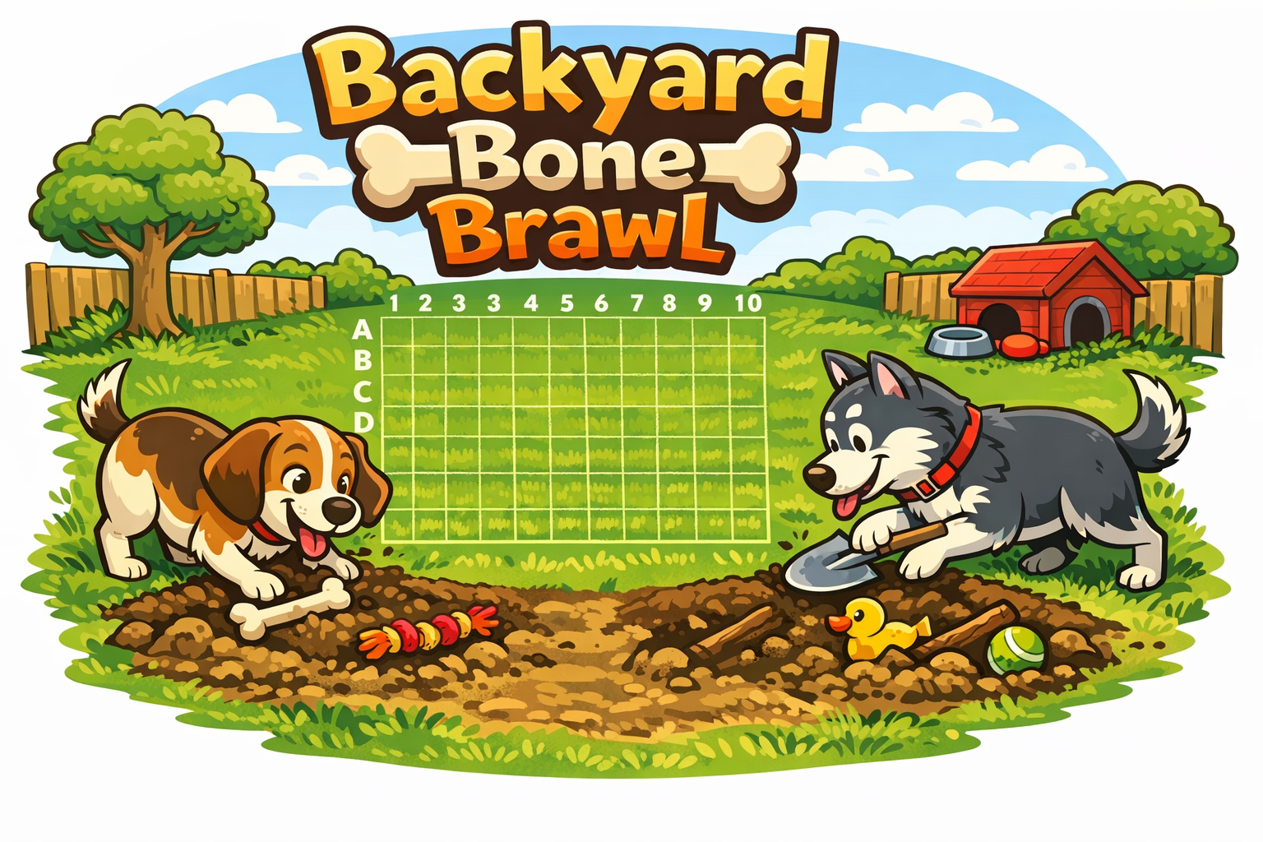

Goals of the Assignment
The goal of this assignment is to work on a team of 3 to implement a software system that is significantly larger and more complex than a typical assignment. You will work with your team to design a solution, break the work into tasks that can be completed together or separately, and demonstrate good software engineering practice, including testing and version control. Please read this document in its entirety before seeking help from the course staff. It is also a very good idea to discuss any questions you have with your team before asking for help.

Background
Backyard Bone Brawl is a turn-based strategy game where two rival dogs compete to dig up each other's buried toys hidden across their backyard.

The game begins with each dog secretly burying five different toys (e.g. stick, bone, squeaky toy, etc) of varying lengths in the backyard - a 10x10 grid. Grid rows are identified with letters and the columns with numbers.

Players take turns digging at a coordinate, e.g. A5, and the defender reports whether the dig resulted in:
- A hole (miss)
- A toy part (hit)
- The final toy part (toy has been completely uncovered)

The game ends when all five toys belonging to one dog have been found.

Teamwork
This project will be divided into three parts. The culmination of each part is a fully functioning software system, e.g. a fully playable version of Backyard Bone Brawl that can be played by one user. Each subsequent part will add new feature requirements that must be implemented on top of those delivered previously.

You will work on a team of 3 students as determined by your instructor. Your team will share a GitHub repository that all members will contribute to. All team members are expected to make roughly equal contributions to the project. This does not necessarily mean contributions have to be the same number of lines of code! However, when your submissions are graded, the grader will be looking for repository activity and significant contributions from all team members. Examples of significant contributions include writing new classes, implementing methods, and writing JUnit tests. Working together in the same repository with multiple people presents many challenges, including the dreaded "merge conflict." The more everyone practices the Git Workflow, the less frequent problems will occur and the smaller and easier they will be to overcome.

You are strongly encouraged to meet with your team, in person or virtually, as often as you can during the project. Pair Programming is an excellent technique for working together on a project. When pair programming, one team member plays the role of the "driver" and writes code to implement new features or bug fixes. The remaining team member(s) play the role of a "navigator" and observe the driver while they work. Navigators make notes and offer helpful advice to the driver. When pair programming, it is important that you switch roles regularly, e.g. every 15-20 minutes - the driver should push their code to the repository and allow someone else to pull the code to their own computer and take over. This technique also ensures that all team members are familiar with the entire codebase, and can learn from each other.

Please note that an experienced programmer writing code for long periods of time while their team members watch is not "pair programming." This is called "showing off" - it is not an effective tool for teaching or learning and often results in lower-quality code. If your team members come to you for help with a tricky feature, it is far more effective to walk them through a solution than it is to write it yourself while they watch.

Being part of a team means you don't have to tackle problems alone. If you encounter difficulties with design, coding, or debugging tasks, don't hesitate to seek assistance from your team. Prior to reaching out to your instructor or CA for help or with questions, ensure you've discussed them with your team.

After the final submission of the project, your instructor will conduct a peer evaluation, which will give you and your teammates an opportunity to provide feedback about your team members and their contributions. You will also be asked to evaluate yourself. Your participation in the peer evaluation will count towards a small part of your grade. Your final project grade may be adjusted based on your individual contributions and your peer evaluations.

Constraints
To ensure the project remains achievable within the timeframe, the implementation will adhere to the following constraints.
- The User Interface for Part 1 will be a Command Line Interface (CLI).
- The game will be played by a single player, squaring off against a Cyber Pup (computer).
- Once the game is over or the player quits, the client should terminate.
- At the start of the game, one of each toy for both the player and the Cyber Pup will be randomly buried in yard coordinates on the grid. Toys may not overlap yard coordinates.
- The player will always go first.
- Immediately after each dig by the player, the Cyber Pup will automatically take their turn and dig (unless the player has uncovered the final toy part with their dig and hence has won the game).
- The grid rows will be lettered 'A' - 'J' and columns will be numbered 0 - 9.

(Partial) Design
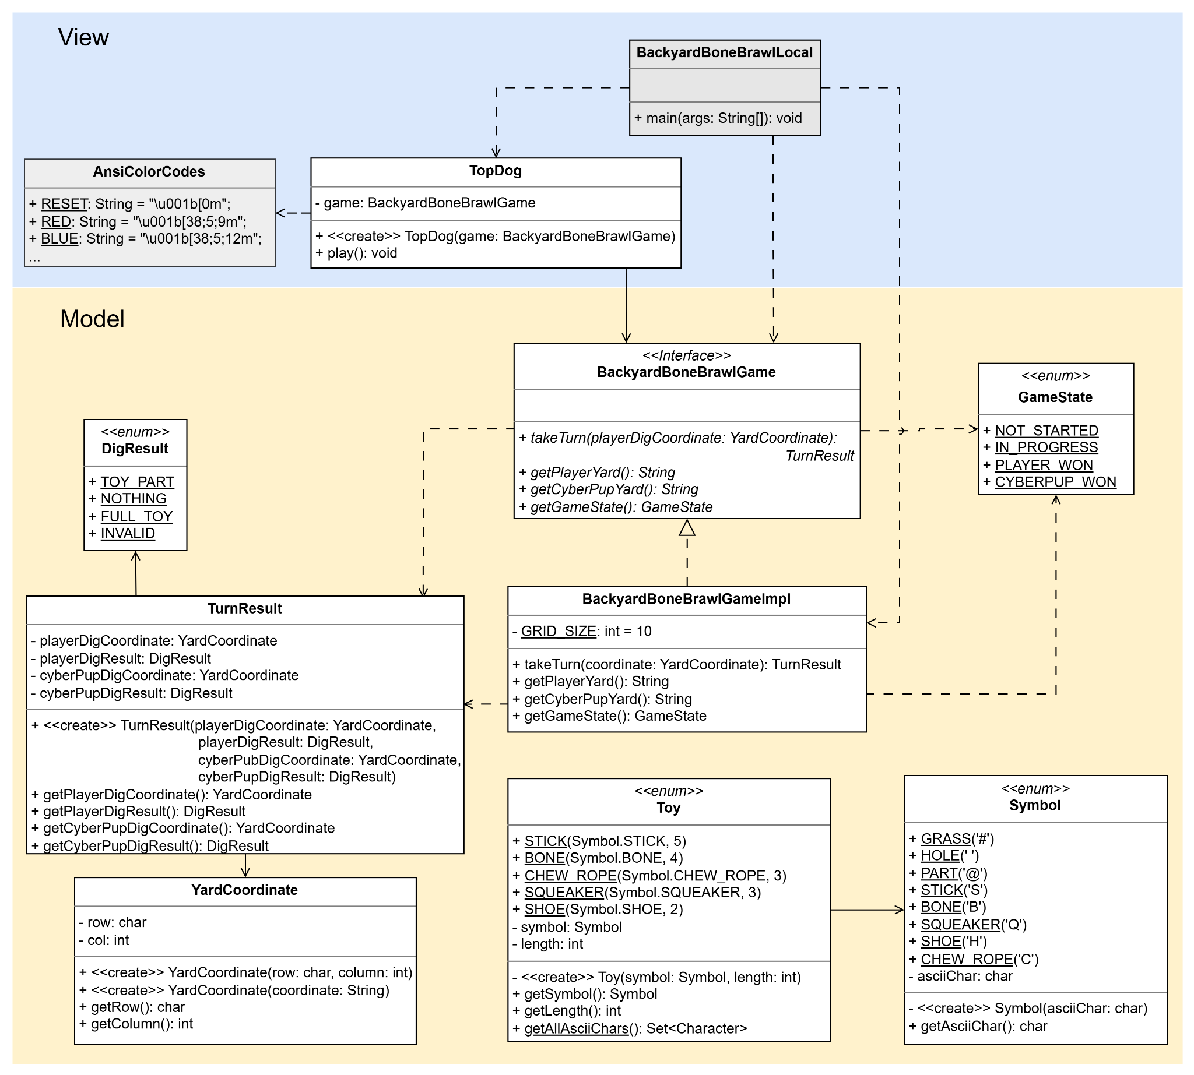

While you have a lot of freedom as you design your solution to the project, you are required to include the classes and enumerations in the UML depicted above in your solution. If you feel your design or solution must deviate from the diagram above, please discuss with your instructor or TA.
Model
- Symbol - represents the state of a specific coordinate on the yard and provides a mechanism for the model to encode the yard contents so that the view classes can display them.
- YardCoordinate - a row and column space in the yard.
- Toy - identifies each type of toy in the game, along with its symbol and length.
- DigResult - indicates the result of digging at a coordinate.
  - TOY_PART - A part of a toy was found.
  - NOTHING - No toy part was found.
  - FULL_TOY - The final part was undug and the full toy has been found.
  - INVALID - the player's coordinate was off the yard grid, bad format, or already dug.
- GameState - indicates the current state of the game.
- TurnResult - stores the result of one complete turn, both player and Cyber Pup.
  - Note: If the player's DigResult is INVALID or the player won, Cyber Pup will not take its turn, and therefore the Cyber Pup's fields in TurnResult are meaningless.
- BackyardBoneBrawlImpl - the implementation of the core game logic, control, and state management.
  - takeTurn(coordinate: YardCoordinate): TurnResult - executes the player's dig at the given coordinate. Assuming the player's dig was valid, and the game is not over, Cyber Pup will take its turn. The returned TurnResult will reflect the outcome.
    - Cyber Pup should pick a random yard coordinate that has not been previously dug at.
  - getPlayerYard(): String - returns a String representation of the player's yard. The returned String is not required to be display-ready; view classes are responsible for interpreting and rendering it for the user.
  - getCyberPupYard(): String - Same as the getPlayerYard() above, except the CyberPup's toys are omitted - only found parts (hits) and holes (misses) are represented.
  - getGameState(): GameState - returns the overall game status.
- BackyardBoneBrawlGame - defines the game operations that the view classes will use.

View
- BackyardBoneBrawlLocal - initiates the game by
  - Creating a BackyardBoneBrawlImpl object.
  - Creating a TopDog object with the BackyardBoneBrawl object.
  - Calling play() on the TopDog object.
This class is provided to you and should not be changed.
- TopDog - plays the game by
  - Prompting and receiving user input.
  - Calling the appropriate BackyardBoneBrawl methods.
  - Displaying the game status to the user.
- AnsiColorCodes - A series of static strings of escape sequences used in terminals to add color to text. This class is provided to you. You may add additional color codes if desired.

Requirements
- Unless otherwise specified, all of the classes, interfaces, and enumerations that you create must be in the bbb.model or bbb.view packages. Once you have at least one class or enumeration in each package, you can delete the delete_me.txt file, as it only serves as a placeholder.

- You must write JUnit unit tests for all classes in the bbb.model package. You should attempt to make your tests as thorough as possible. In general, the team member that creates a class should be responsible for testing it. You do not need to write JUnit tests for classes in the bbb.view package.

- Implement each of the classes and enumerations described in the previous section. Consider:
  - Implementing toString() methods for some of the classes.
  - Whether or not some of the classes will need to be used in hashing data structures. If so, you will want to implement the equals(Object) and hashCode() methods.
  - What supporting classes or private methods are needed for a clean design and implementation. You will need additional classes.

- Once the game is started
  - The user should be prompted to enter a dig coordinate, or they can enter quit to quit the game.
  - After the turn, the following should be displayed:
    - The coordinate that the player dug at and the result.
    - The coordinate that the Cyber Pup dug at and the result.
    - The Cyber Pup's yard
    - The player's yard
  - If an invalid dig attempt is made, the player should be re-prompted to enter a new dig coordinate.
  - Be sure to handle invalid input.

- See Example Output below for further guidance.

Ansi Color Codes
The yard coloring in the Example Output is achieved by the use of Ansi color codes. In the bbb.view package, you have been provided an AnsiColorCodes class for your yard display. You may add color code constants to this file if needed.
public class AnsiColorCodes {
public static String RESET = "\u001b[0m";
public static String RED = "\u001b[38;5;9m";
public static String BLUE = "\u001b[38;5;12m";
public static String ORANGE = "\u001b[38;5;130m";
public static String GREEN = "\u001b[38;5;28m";
public static String WHITE = "\u001b[38;5;15m";
public static String BROWN = "\u001b[38;5;94m";
public static String YELLOW = "\u001b[38;5;11m";
public static String MAGENTA = "\u001b[38;5;13m";
public static String GOLD = "\u001b[38;5;220m";
public static String PURPLE = "\u001b[38;5;5m";
public static String LT_GRAY = "\u001b[38;5;7m";
public static String CYAN = "\u001b[38;5;14m";
}

To display a character in color, create a string by concatenating the code, the symbol, and reset. For example, to display grass, use
AnsiColorCodes.GREEN + "#" + AnsiColorCodes.RESET

Pro Tips
- Integration between the view and model always takes longer than you anticipate. It is recommended that the team first focuses on the minimum end-to-end implementation of starting a game and displaying the initial yards.
- Start with a smaller yard and fewer number of toys for initial development and debugging.

Submission Instructions
Your solution must be pushed to your team's GitHub repository before the submission deadline.

Example Output
You should attempt to match the format of the provided output as closely as possible. You have leeway on the colors and the display characters. For brevity, the output is for a 5x5 yard grid with 3 toys.

Welcome to Backyard Bone Brawl!
Can you dig it?

CyberPup's Yard:
0 1 2 3 4
A # # # # #
B # # # # #
C # # # # #
D # # # # #
E # # # # #

Player's Yard:
0 1 2 3 4
A # H # # #
B # H # C #
C # # # C #
D # # # C #
E B B B B #

Enter dig coordinates (e.g. A5) or 'quit':
You dug at C2: Nothing!
CyberPup dug at E1: Toy Part!

CyberPup's Yard:
0 1 2 3 4
A # # # # #
B # # # # #
C # # # #
D # # # # #
E # # # # #

Player's Yard:
0 1 2 3 4
A # H # # #
B # H # C #
C # # # C #
D # # # C #
E B @ B B #

Enter dig coordinates (e.g. A5) or 'quit':
Invalid coordinates. Please try again.

Enter dig coordinates (e.g. A5) or 'quit':
Invalid coordinates. Please try again.

Enter dig coordinates (e.g. A5) or 'quit':
Invalid coordinates. Please try again.

Enter dig coordinates (e.g. A5) or 'quit':
You dug at A2: Nothing!
CyberPup dug at B2: Nothing!

CyberPup's Yard:
0 1 2 3 4
A # # # #
B # # # # #
C # # # #
D # # # # #
E # # # # #

Player's Yard:
0 1 2 3 4
A # H # # #
B # H C #
C # # # C #
D # # # C #
E B @ B B #

Enter dig coordinates (e.g. A5) or 'quit':
You dug at E1: Toy Part!
CyberPup dug at E3: Toy Part!

CyberPup's Yard:
0 1 2 3 4
A # # # #
B # # # # #
C # # # #
D # # # # #
E # @ # # #

Player's Yard:
0 1 2 3 4
A # H # # #
B # H C #
C # # # C #
D # # # C #
E B @ B @ #

Enter dig coordinates (e.g. A5) or 'quit':
You dug at E0: Toy Part!
CyberPup dug at A1: Toy Part!

CyberPup's Yard:
0 1 2 3 4
A # # # #
B # # # # #
C # # # #
D # # # # #
E @ @ # # #

Player's Yard:
0 1 2 3 4
A # @ # # #
B # H C #
C # # # C #
D # # # C #
E B @ B @ #

Enter dig coordinates (e.g. A5) or 'quit':
You dug at E2: Toy Part!
CyberPup dug at B1: Final Toy Part!

CyberPup's Yard:
0 1 2 3 4
A # # # #
B # # # # #
C # # # #
D # # # # #
E @ @ @ # #

Player's Yard:
0 1 2 3 4
A # @ # # #
B # @ C #
C # # # C #
D # # # C #
E B @ B @ #

Enter dig coordinates (e.g. A5) or 'quit':
You dug at E3: Final Toy Part!
CyberPup dug at C4: Nothing!

CyberPup's Yard:
0 1 2 3 4
A # # # #
B # # # # #
C # # # #
D # # # # #
E @ @ @ @ #

Player's Yard:
0 1 2 3 4
A # @ # # #
B # @ C #
C # # # C
D # # # C #
E B @ B @ #

Enter dig coordinates (e.g. A5) or 'quit':
You dug at B4: Nothing!
CyberPup dug at D1: Nothing!

CyberPup's Yard:
0 1 2 3 4
A # # # #
B # # # #
C # # # #
D # # # # #
E @ @ @ @ #

Player's Yard:
0 1 2 3 4
A # @ # # #
B # @ C #
C # # # C
D # # C #
E B @ B @ #

Enter dig coordinates (e.g. A5) or 'quit':
You dug at D3: Toy Part!
CyberPup dug at C2: Nothing!

CyberPup's Yard:
0 1 2 3 4
A # # # #
B # # # #
C # # # #
D # # # @ #
E @ @ @ @ #

Player's Yard:
0 1 2 3 4
A # @ # # #
B # @ C #
C # # C
D # # C #
E B @ B @ #

Enter dig coordinates (e.g. A5) or 'quit':
You dug at D4: Toy Part!
CyberPup dug at D4: Nothing!

CyberPup's Yard:
0 1 2 3 4
A # # # #
B # # # #
C # # # #
D # # # @ @
E @ @ @ @ #

Player's Yard:
0 1 2 3 4
A # @ # # #
B # @ C #
C # # C
D # # C
E B @ B @ #

Enter dig coordinates (e.g. A5) or 'quit':
You dug at D2: Final Toy Part!
CyberPup dug at A0: Nothing!

CyberPup's Yard:
0 1 2 3 4
A # # # #
B # # # #
C # # # #
D # # @ @ @
E @ @ @ @ #

Player's Yard:
0 1 2 3 4
A @ # # #
B # @ C #
C # # C
D # # C
E B @ B @ #

Enter dig coordinates (e.g. A5) or 'quit':
You dug at B1: Toy Part!
CyberPup dug at C1: Nothing!

CyberPup's Yard:
0 1 2 3 4
A # # # #
B # @ # #
C # # # #
D # # @ @ @
E @ @ @ @ #

Player's Yard:
0 1 2 3 4
A @ # # #
B # @ C #
C # C
D # # C
E B @ B @ #

Enter dig coordinates (e.g. A5) or 'quit':
You dug at B0: Final Toy Part!
CyberPup dug at C3: Toy Part!

CyberPup's Yard:
0 1 2 3 4
A # # # #
B @ @ # #
C # # # #
D # # @ @ @
E @ @ @ @ #

Player's Yard:
0 1 2 3 4
A @ # # #
B # @ C #
C # @
D # # C
E B @ B @ #

Game Over!
Hot diggity dog! You win!

Due to odd numbers in some sections, teams of 2-4 may be necessary. Your instructor will determine how to adjust your team's grade for the project if you do not have 3 members.
Contributions such as deleting, renaming, or moving files, or adding comments to existing classes are not considered significant on their own.
The specific output will not match exactly if you play on different yard configurations or make different moves.

